Class Based Javascript Game

Download the game files into a folder and run the index.html file. The game should actually work, but all the items are just grey squares.

The classes for the objects are:

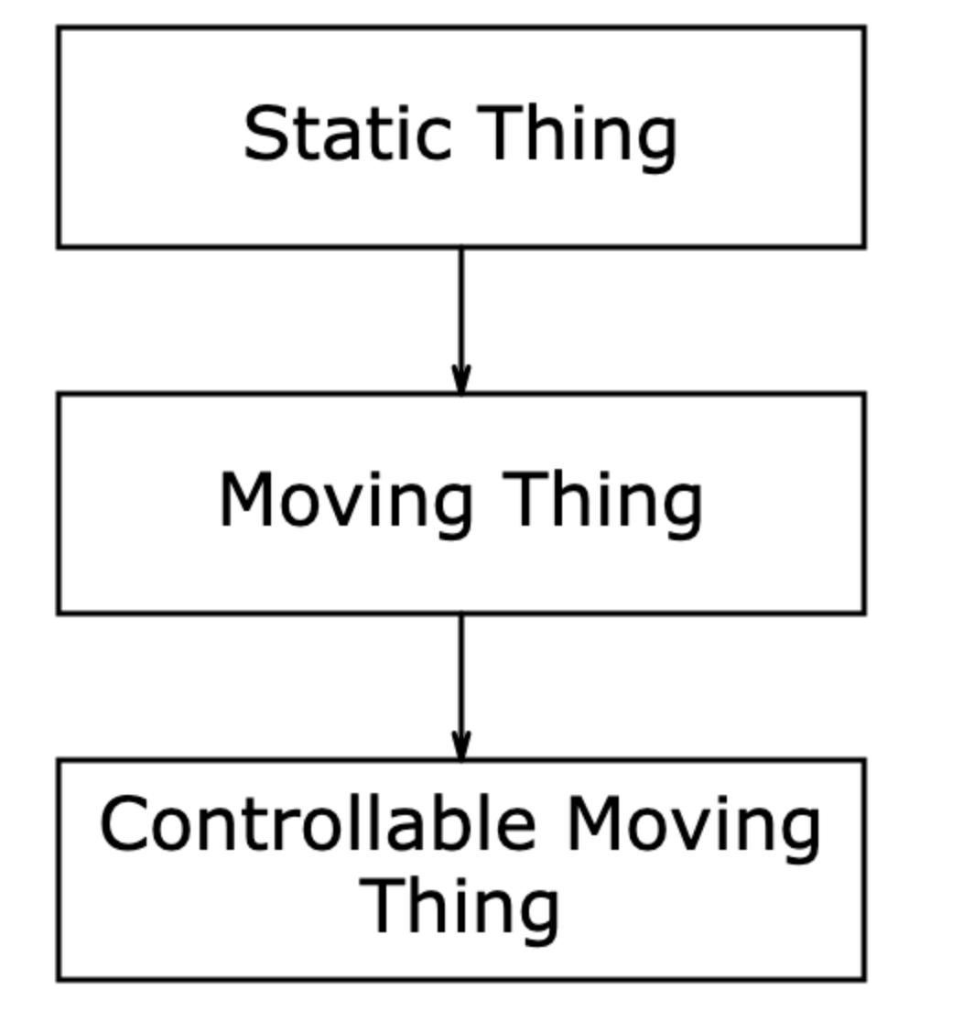

Task 1:

Edit the file thingClasses.js and add comments for each on the methods explaining what they do.

Task 2:
Make some classes that inherit from the existing ones, like this. Initially the new classes just need to override the draw() method.

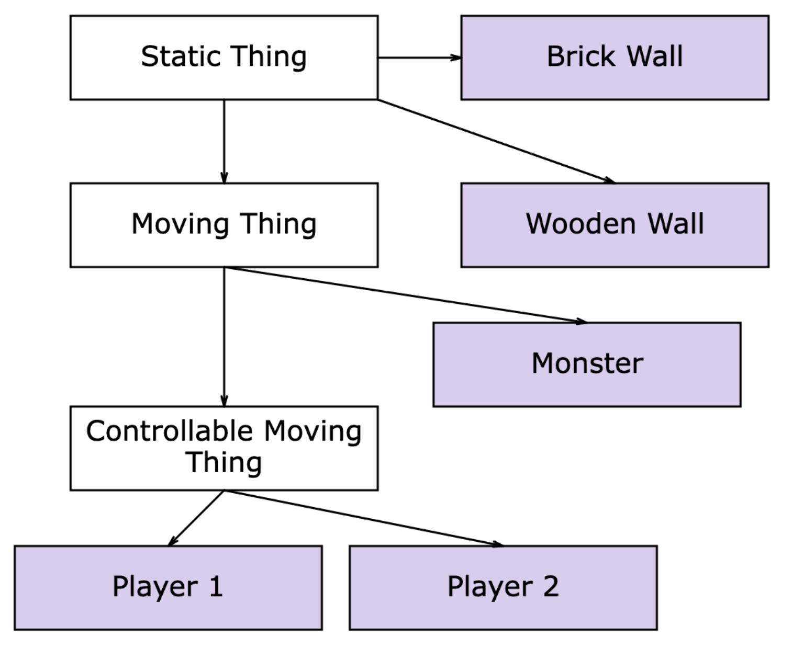

Tip:

If you want to use an image rather than a shape, here is what you do:

Add the image to the page (e.g. <IMG ID="stone" SRC="images/stone.png")

Then override the constructor to include the image you want to use as one of the class attributes, something like this

constructor(x,y,context)
{
super(x,y,context);
this.image = document.getElementById("stone");
this.width = this.image.width;
this.height = this.image.height;
}

When you draw the object, do something like this:

draw()
{
this.context.drawImage(this.image,this.left(),this.top())
}

Task 3

Add some features. You can think of your own, but here are some suggestions. Ideally add more classes that inherit from the existing ones:

Add a second monster class which has a health score, so that when the ‘kill’ method is called it decrements the counter, and only sets it to be dead when the counter is zero. You could also make the appearance different if it less healthy.

Add a counter to the player class which you can increment every time the player ‘scores’ by hitting a monster. During the update function you could display the scores.

Adapt the player 2 class so that it has a ‘boost’ key that increases its speed.

